INTRODUCTION

NAME - JASHAN BANSAL

UNIVERSITY ID – 2010991897

BRANCH – COMPUTER SCIENCE

ADDRESS-SHAHEED BHAGAT SINGH ROAD, BARNALA

INSTRUCTOR NAME –

MR. LAVISH ARORA

WORKED ON THREE PROJECTS WITH THE GUIDANCE OF THE INSTRUCTOR

NAME OF PROJECTS

1. DIGITAL DEN

(SPOT OF THE DIGITAL)

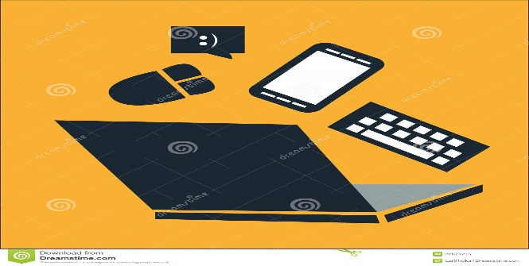

1. SPEXY

(See better see clear)



1. Portfolio



PROJECT 1

Is based on the HTML, CSS AND JAVASCRIPT.

1. HTML -

* HTML is the standard markup language for creating Web pages
* HTML describes the structure of a Web page
* HTML consists of a series of elements
* HTML elements tell the browser how to display the content

1. CSS –

* You can write CSS once and reuse the same sheet in multiple HTML pages.
* To make a global change simply change the style, and all elements in all the webpages will be updated automatically.
* CSS is considered a clean coding technique, which means search engines won’t have to struggle to “read” its content.

1. JAVASCRIPT –

* **JavaScript** is the world most popular lightweight, interpreted compiled programming language.
* It is also known as scripting language for web pages. It is well-known for the development of web pages; many non-browser environments also use it.
* JavaScript can be used for [Client-side](https://www.geeksforgeeks.org/server-side-client-side-programming/) developments as well as [Server-side](https://www.geeksforgeeks.org/server-side-client-side-programming/) developments.

WELCOME TO DIGITAL DEN

* *The one stop electronic online store for Premium lifestyle gadgets from across the globe.*

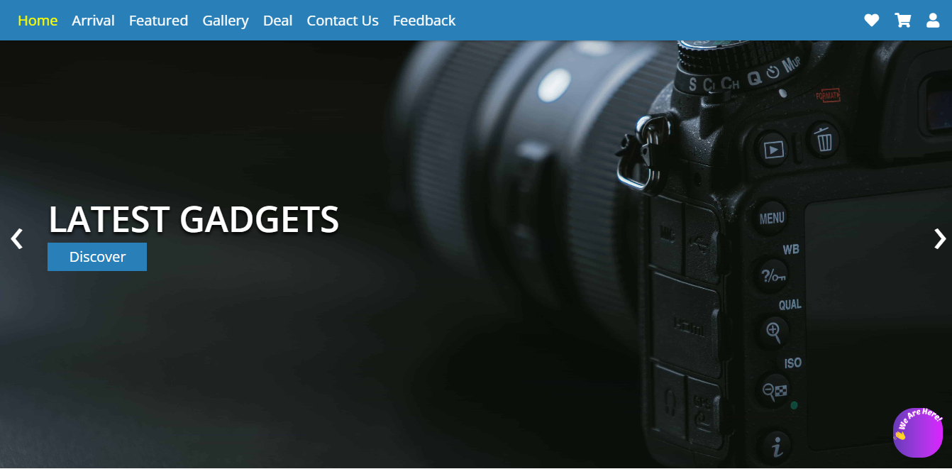

* *Shop for unique****electronic gadgets****& accessories****online****from the overseas market at low prices in India.*
* *Customers have the option to order classic as well as trendy lenses and eyeglasses online as well as at the Spexy retail store.*
* *These benefits include unlimited free replacements, faster deliveries, and access to exclusive products*

ARRIVAL SECTION

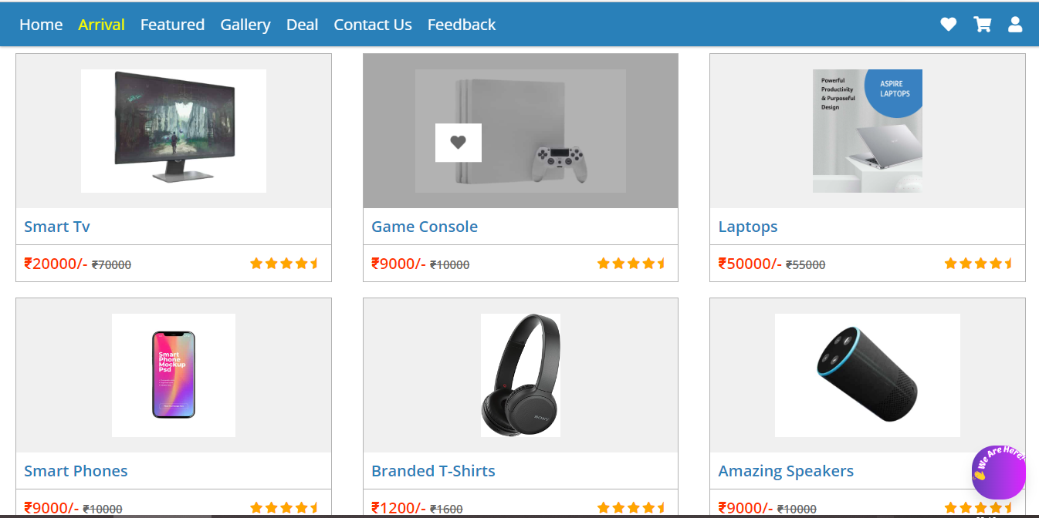

FEATURED SECTION

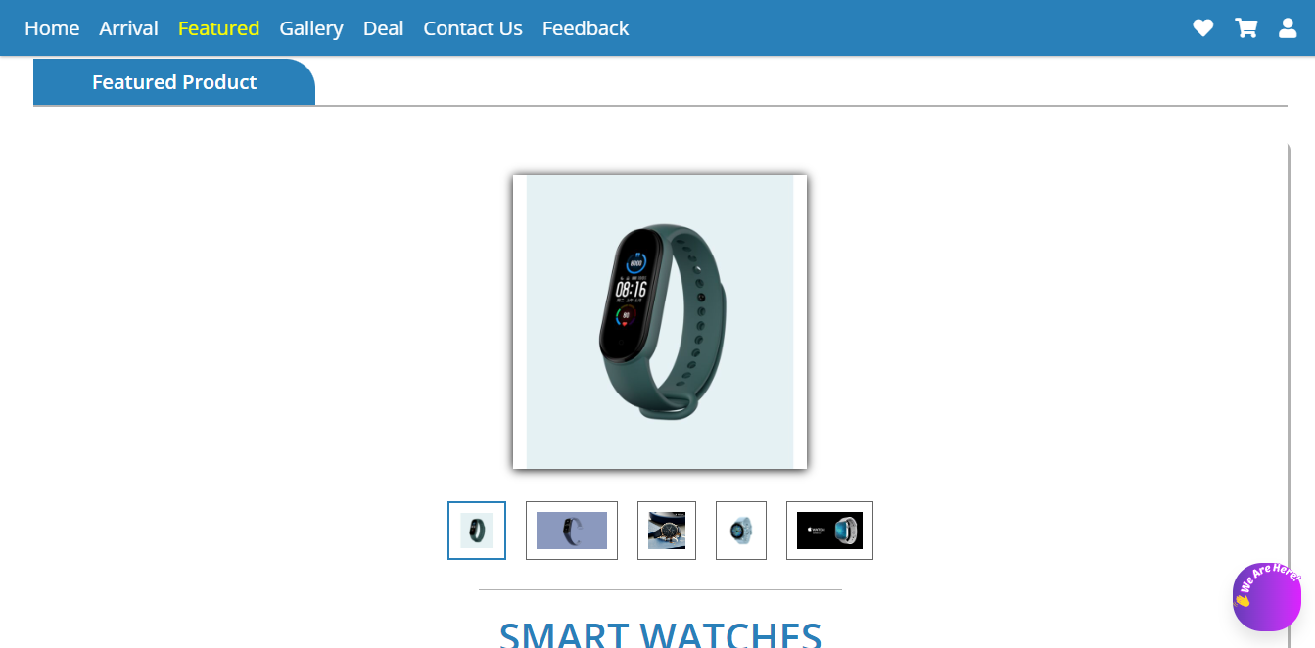

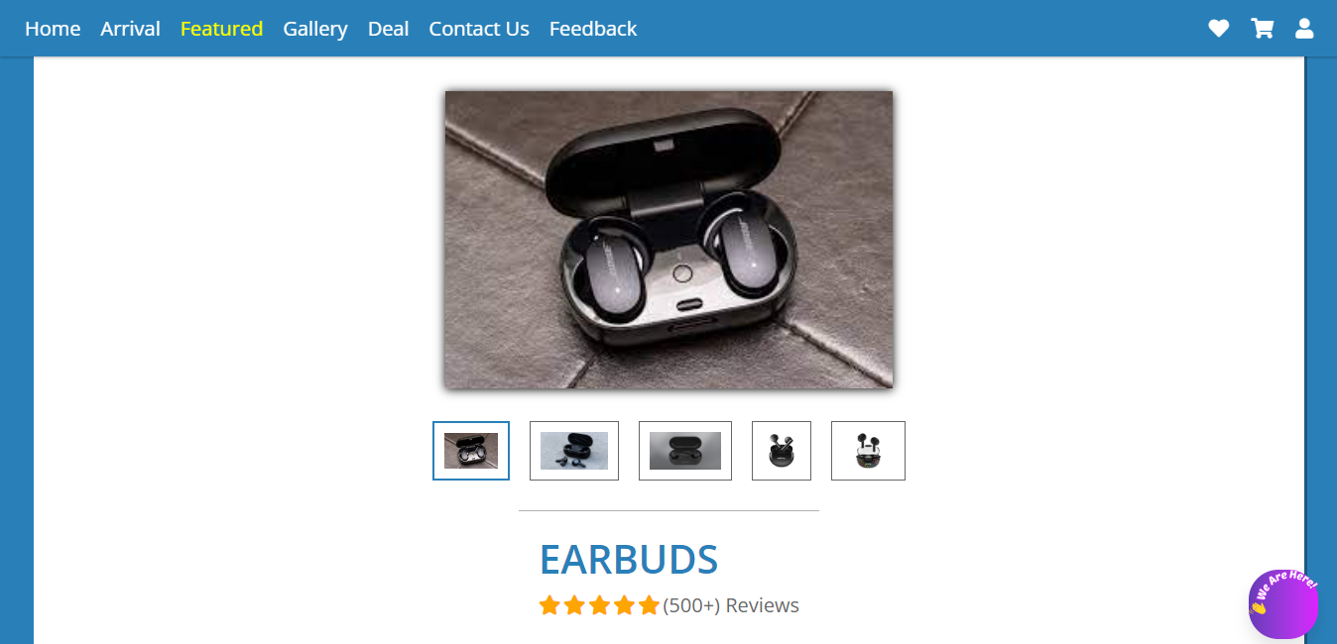

GALLERY WITH REVIEWS

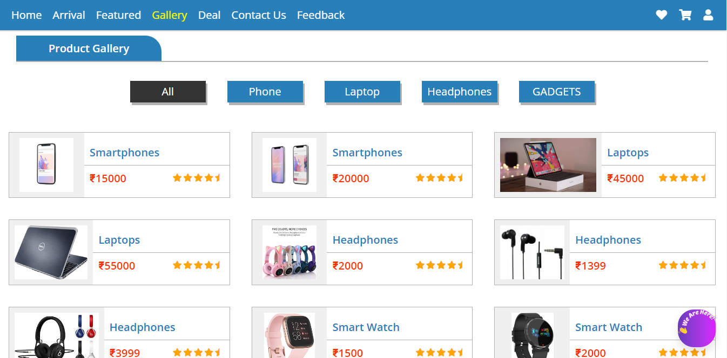

DEALS

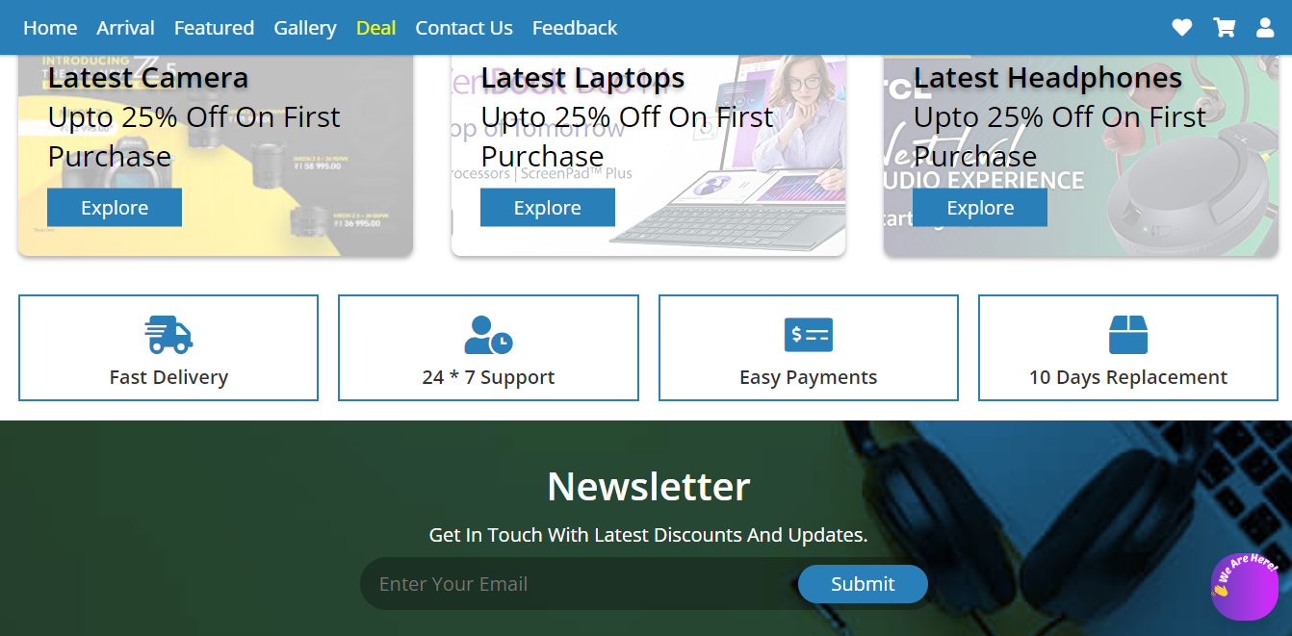

FEEL FREE TO CONTACT US

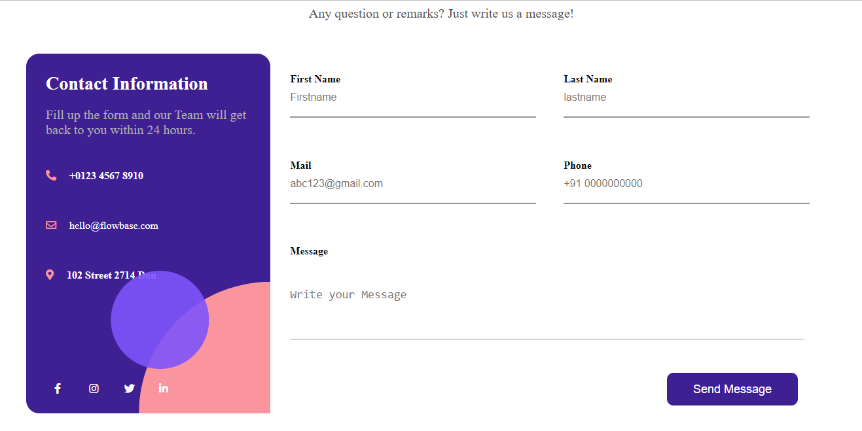

WE WILL LOVE TO GET YOUR REVIEWS TO IMPROVE

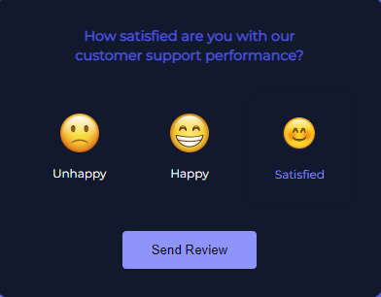

GITHUB LINK FOR PROJECT 1 –

https://github.com/Jashan24/DIGITAL-DEN.git

PROJECT 2

(Is based on Bootstrap 3 and 4)

Bootstrap -

* Bootstrap’s responsive CSS adjusts to phones, tablets, and desktops
* Mobile-first styles are part of the framework
* Bootstrap is compatible with all modern browsers (Chrome, Firefox, Internet Explorer, Safari, and Opera)
* You don’t need to know HTML and CSS well to use bootstrap, it’s a plus if you’re a backend developer and need to do some UI changes.
* It’s fully customizable, I can choose which components I’d like to use and use variables file to get do even more color and behavior customization.

 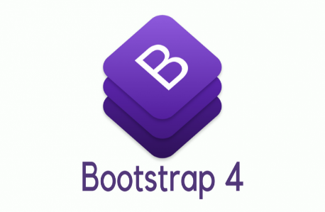

WELCOME TO SPEXY

*. SPEXY provides it's customers to find a wide range of eye-wear for a good, smart, ultimate and a new look.*

* *Here you can find the latest and trending Specs , goggles , Contact lens , kids frame aNd more amazing stuf*

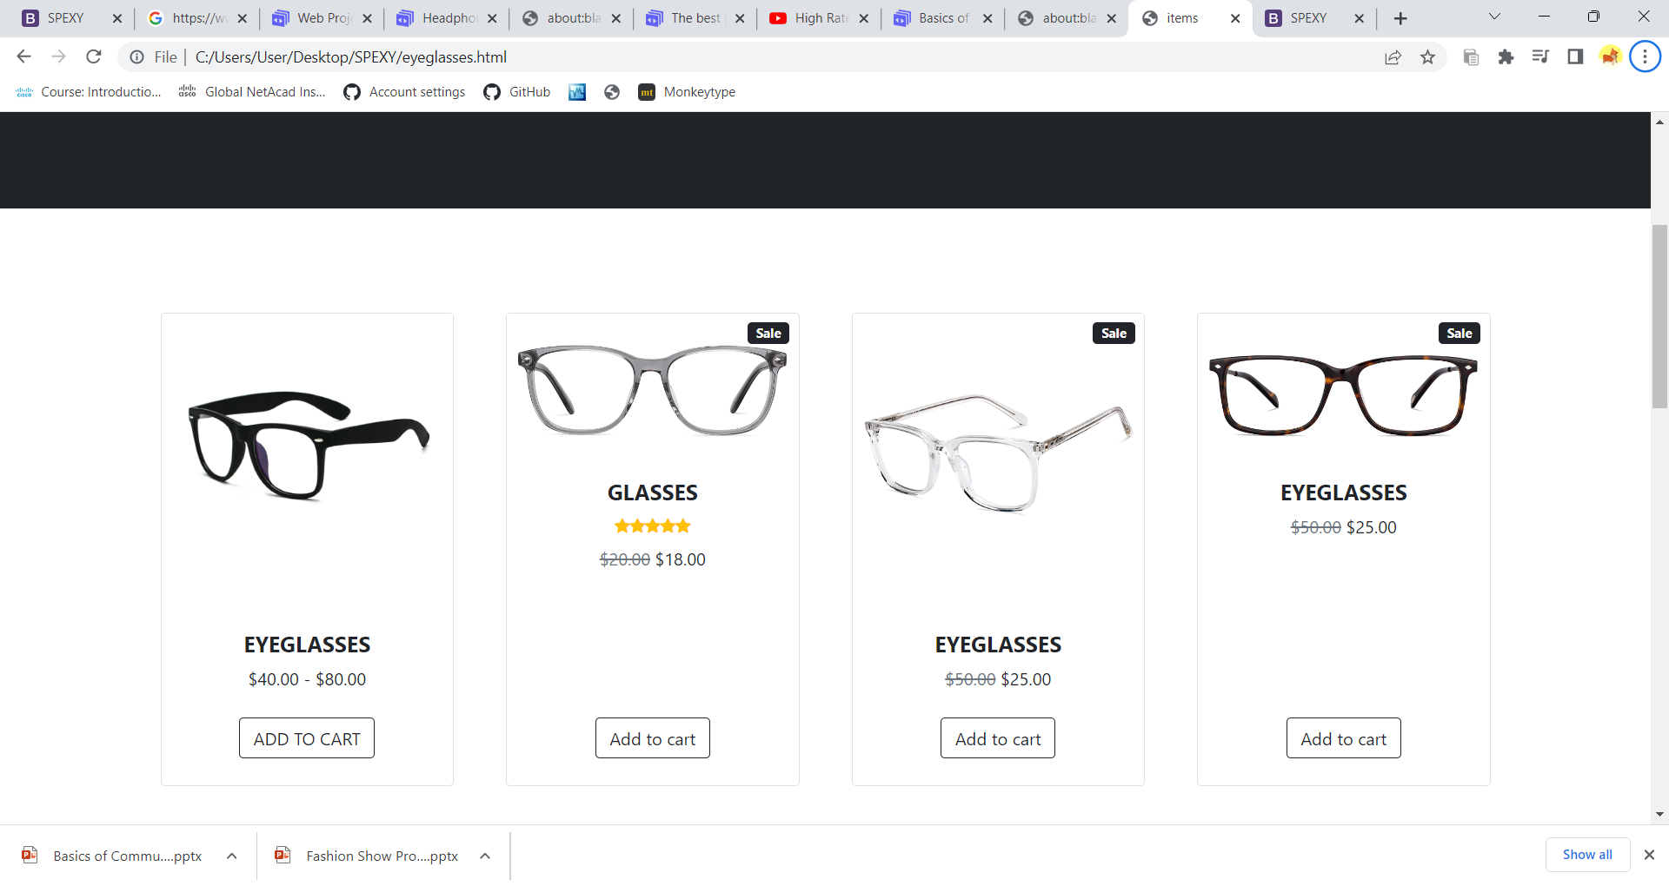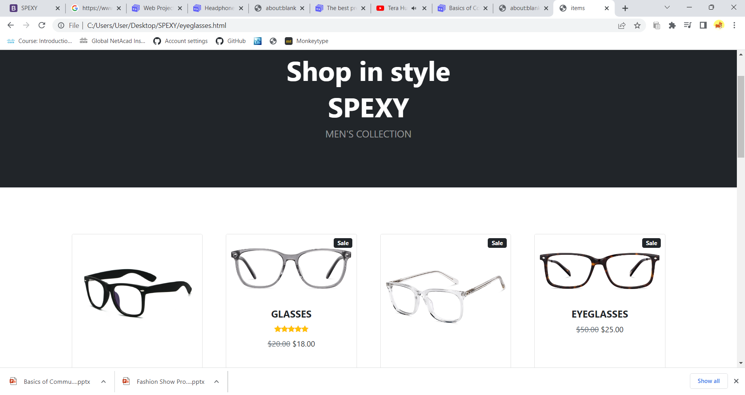

CARTITEM

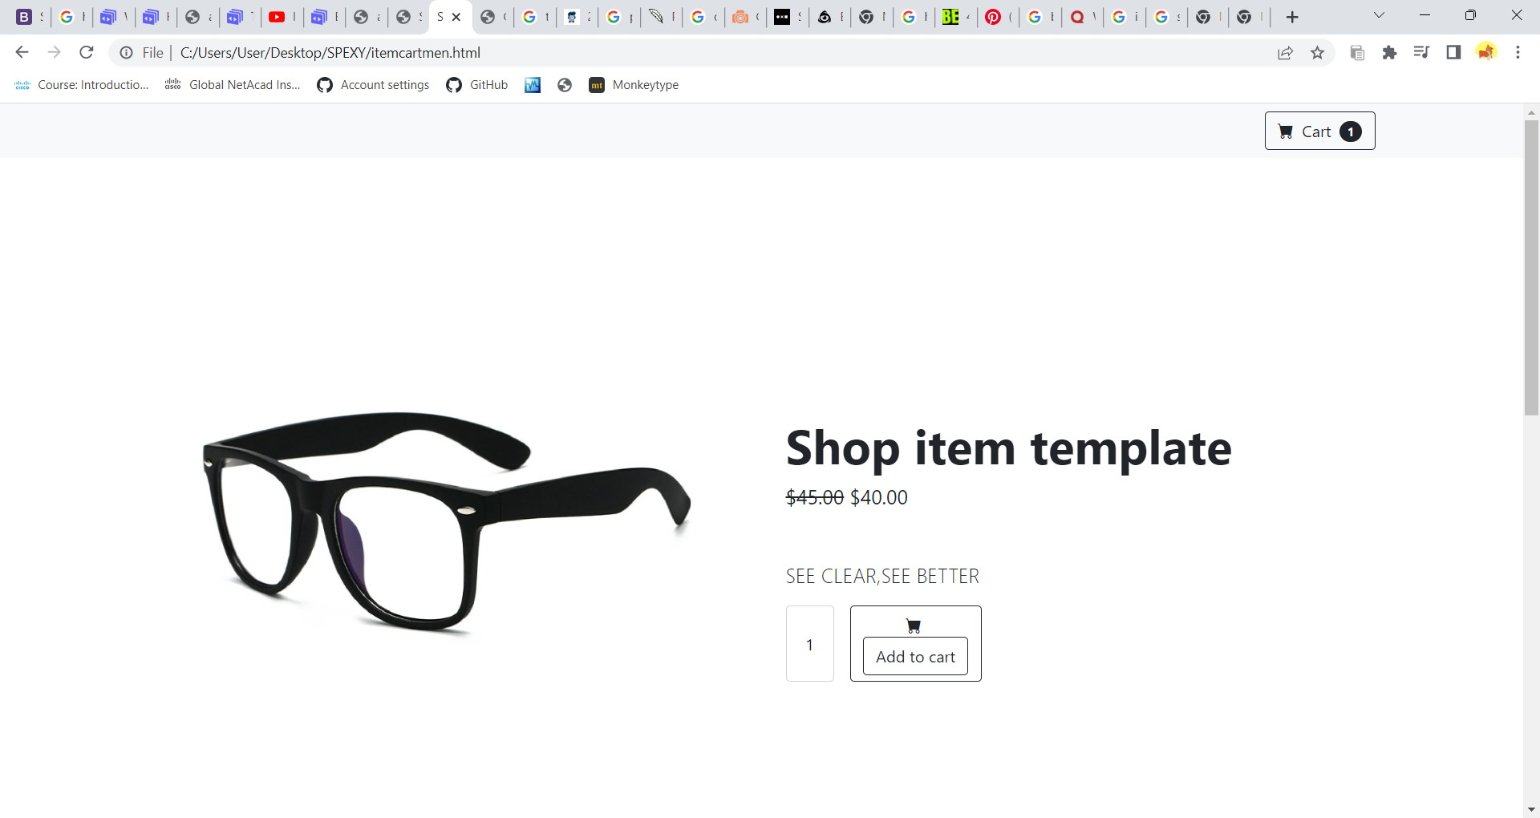

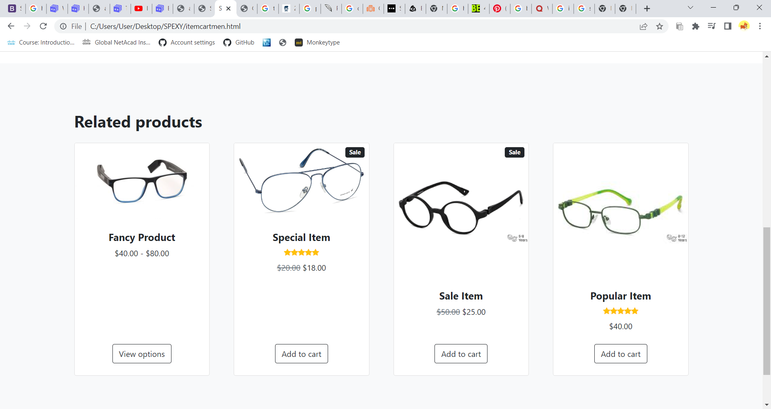

* *Customers have the option to order classic as well as trendy lenses and eyeglasses online as well as at the Spexy retail store*
* *We identified a need in the market and saw an opportunity to fill that void.*
* *Premium Membership is that offers several benefits over the regular membership.*
* *These benefits include unlimited free replacements, faster deliveries, and access to exclusive products.*

SIGNUP / SIGNIN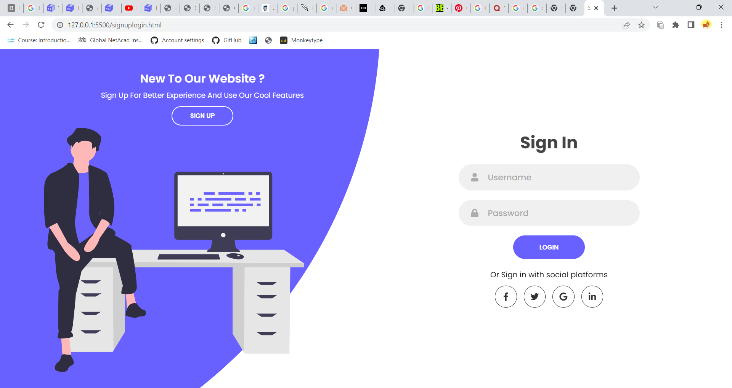

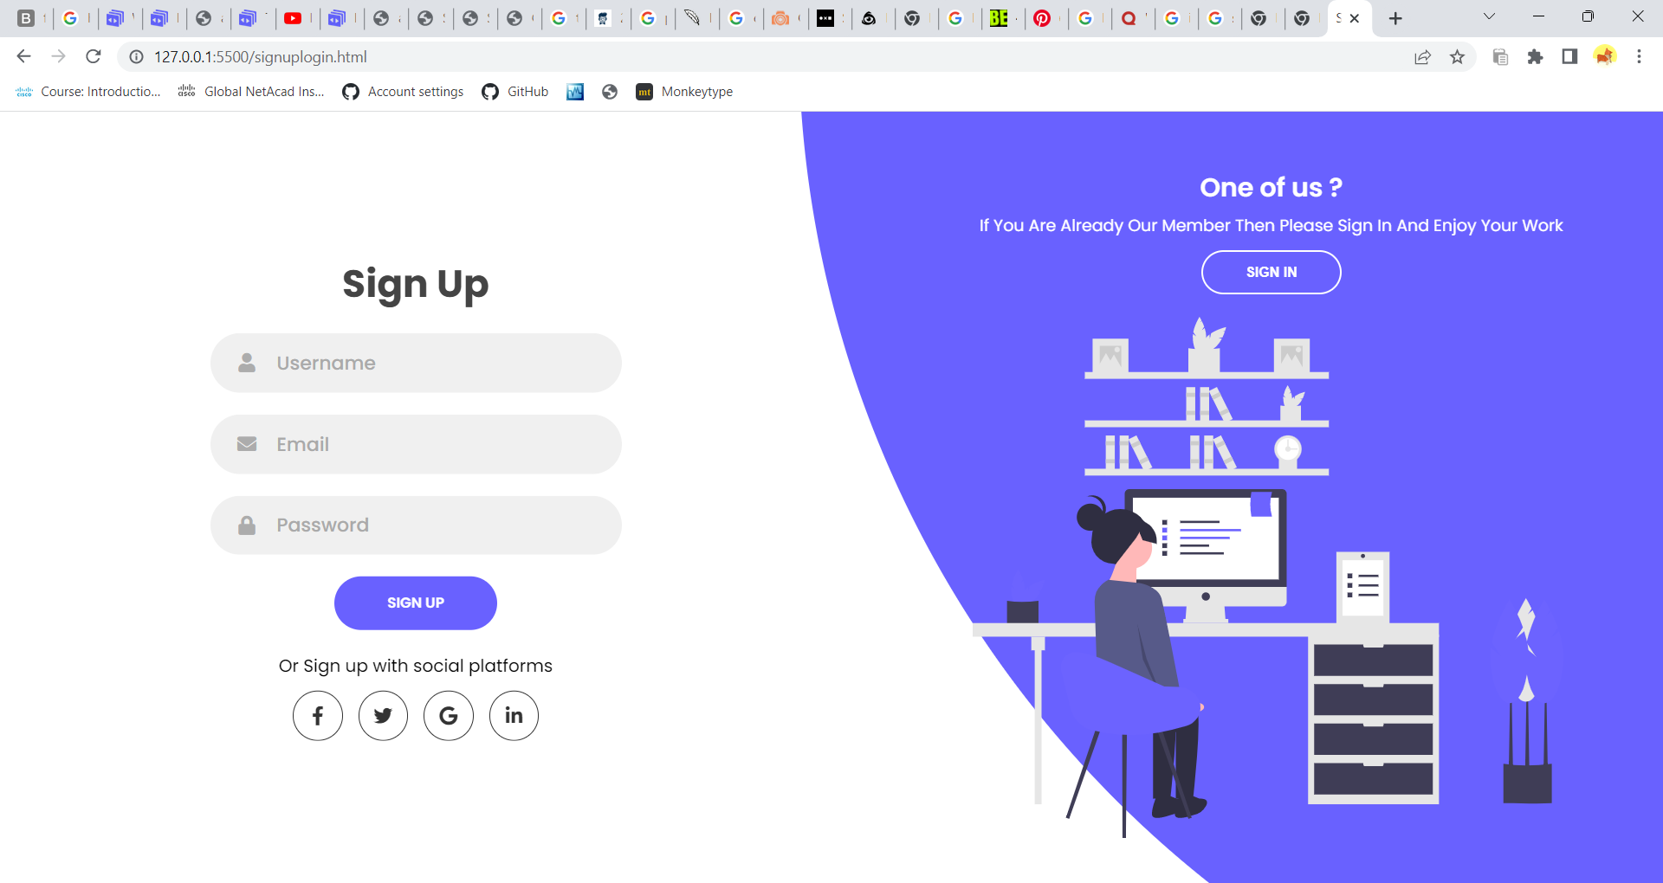

CHECKOUT

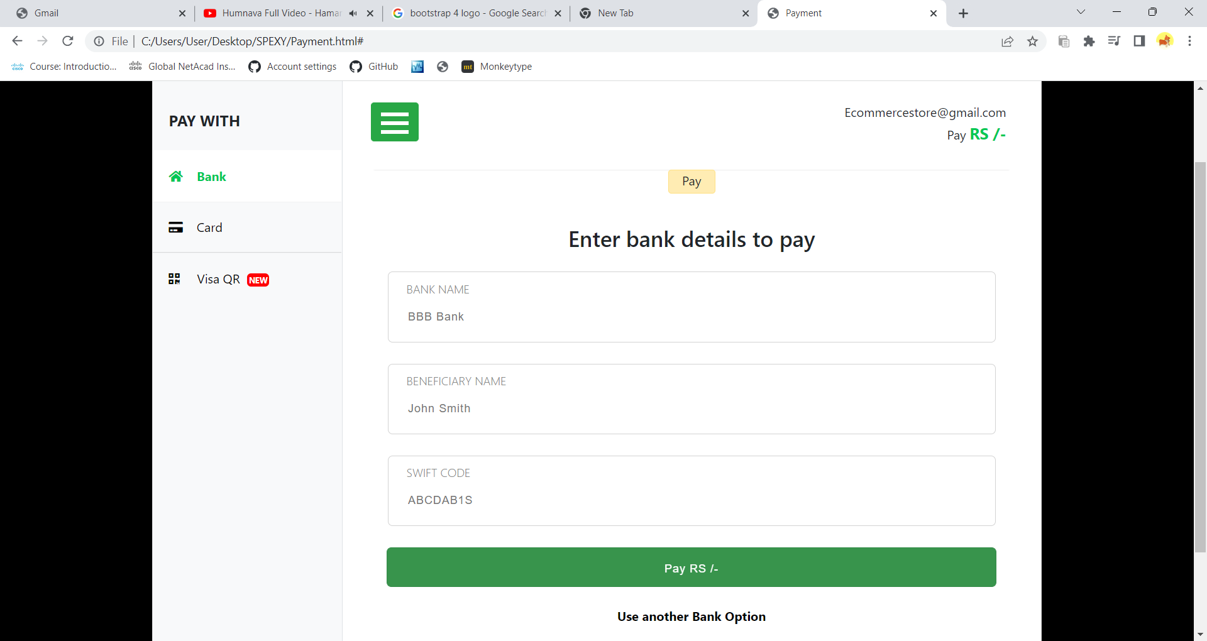

WE ARE HERE TO LISTEN FROM U

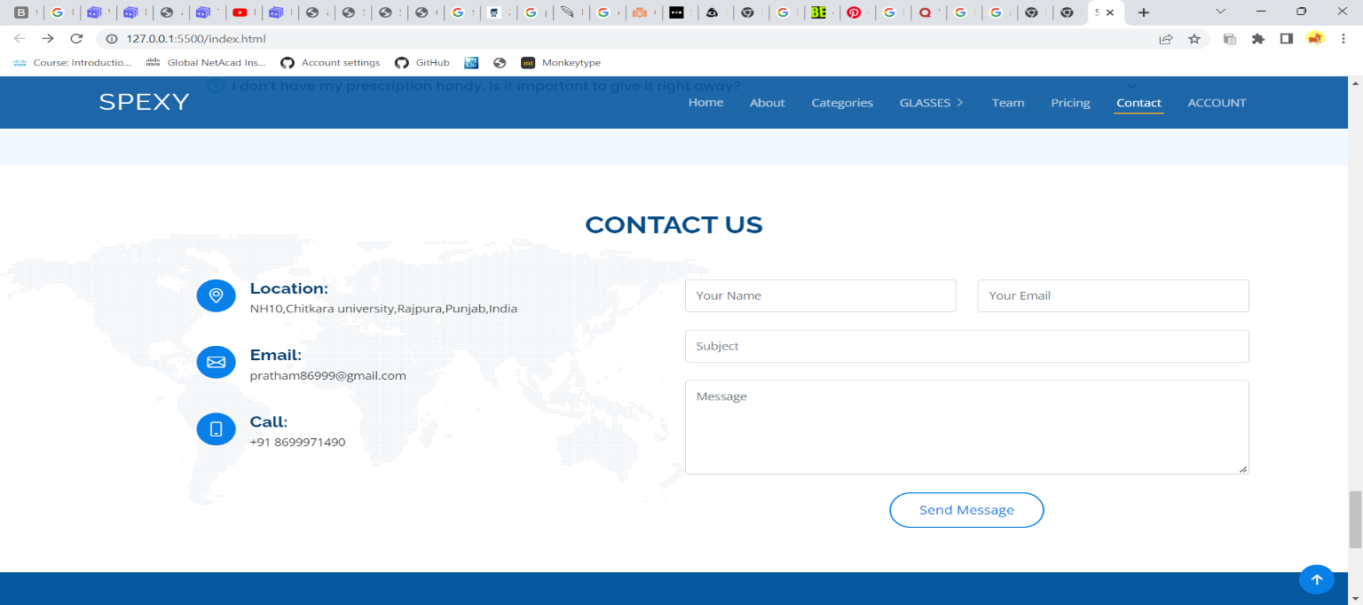

GITHUB LINK FOR PROJECT-2 <https://github.com/Jashan24/SPEXY.git>

PROJECT 3

PORTFOLIO



WELCOME TO MY PORTFOLIO

Desktop view



Smartphone view

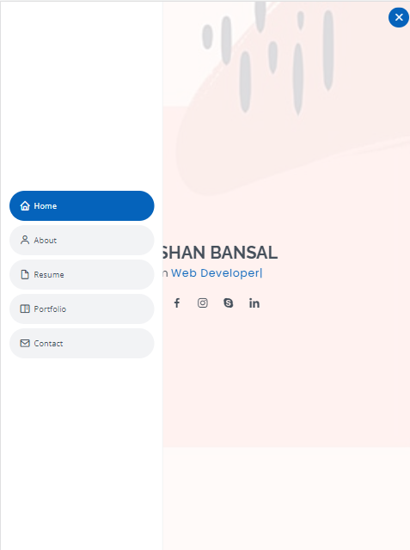

About me

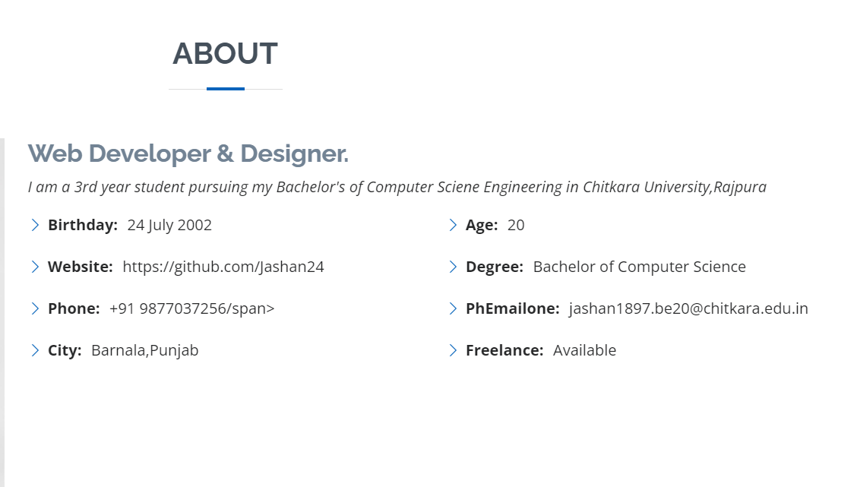

Some of my Skills

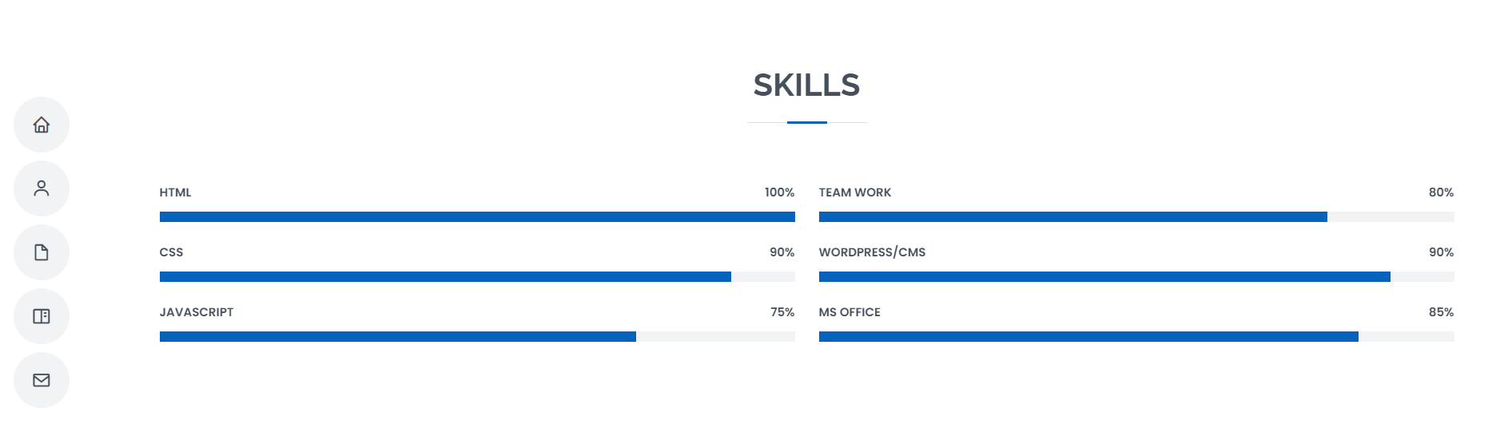

EDUCATION/EXPERIENCE

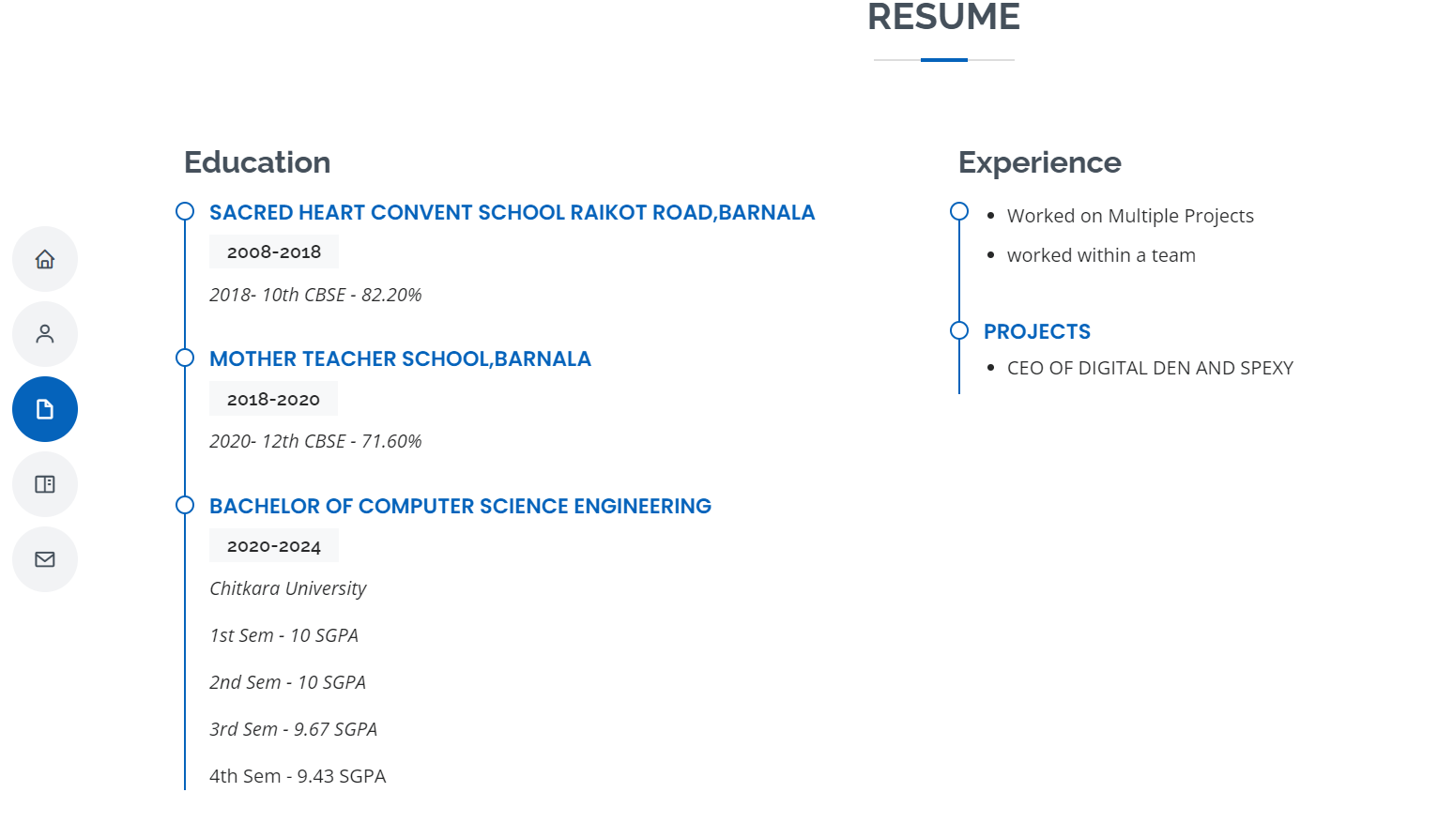

Some 0f my works

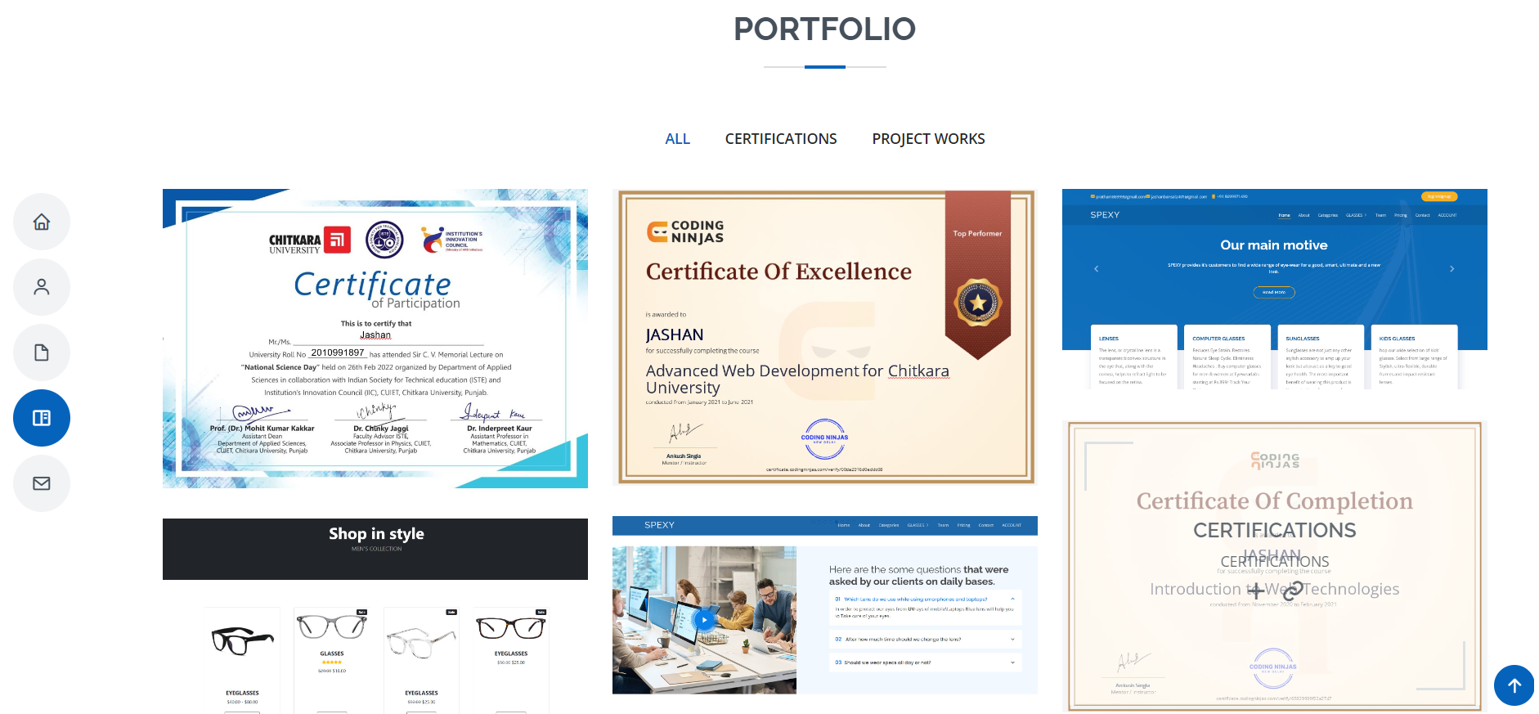

I would love to hear from u

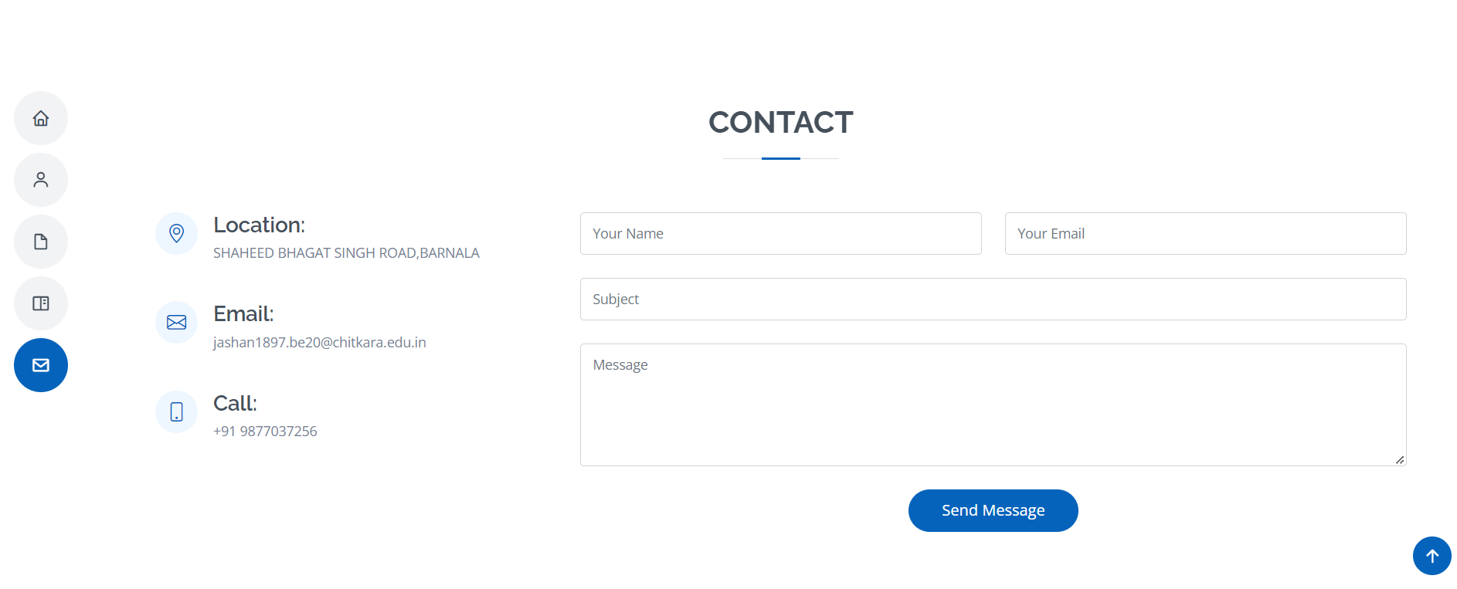

GITHUB LINK FOR PROJECT-3

https://github.com/Jashan24/PORTFOLIO.git

THANK YOU